Final Project Proposal - CP630

Name: Ma Luo

Email: luox1180@mylaurier.ca

Overview / Introduction

Within our course, we have experienced a lot of frameworks based on big data solutions. Messaging service and data persistence techniques would help us deal with data transactions with low cost, and Spring framework gives us an overview on the full-stack Java development.

As for our final project I would like to build up an ordering service which contains the import, sales and stock management. I will think of 3 traditional relational tables which will be explained in the next section. Users should be able to add an item to inventory through a form interface, import goods within the inventory and sell the goods through another ordering portal.

After a couple of overall test runs on the system, we should be able to see which product gives the best profit and which ones go fast within a shorter term. Then at last, we can perform dynamic programming and help make an importing strategy based on the item list, and see how we can maximize our profit.

I will try my best to make use of enterprise beans and encapsulate the logic inside.

Specifications

Database design:

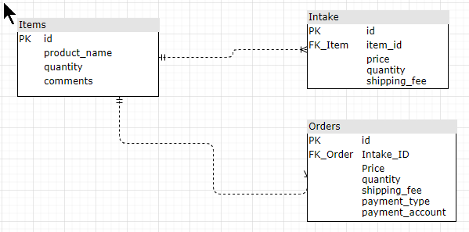

Workflow:

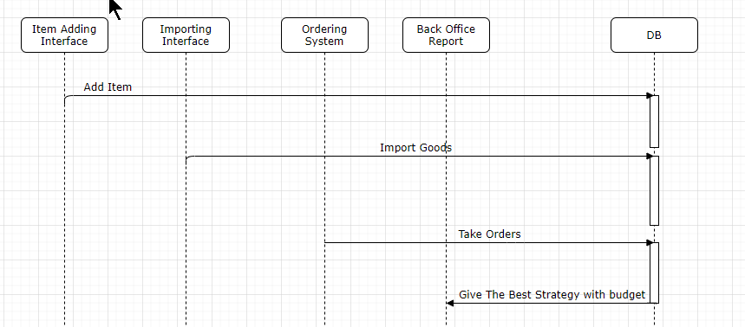

Tech Specification List:

Data would be available at:

|  |  |
| --- | --- |
| Front-end | Backend |
| Spring MVC plus a bit Angular | EJB, JPA and Soap Service |

1. Spring MVC framework would be required to implement a full stack cycle with front-end, enterprise beans and database.
2. Will work around JPA with a Mysql database host on XAMPP for data persistence.
3. Logics will be encapsulated in enterprise beans
4. Utilize soap service and return an analytical report based on the current orders.
5. With the soap service, generate a dashboard for profit and sales price per item and perform map-reduce map items with importing price (weight) and profit (value) for each item. That is the model object we are going to put into DB and then, a 0/1 knapsack Scala model will be performed.

Task list:

1.Initially imported from downloaded excel file with client-based simple Java File.

2.Data persistence with Hibernate, with h2b transforming Mysql tables to entities.

3.Adding CURD logic to entity beans with test cases. Front-end will be saved for optional.

4.Spring MVC - generate dashboard and dashboard service with MAP-Reduce. Ordering part could be saved later.

5.Scala code to do analysis with the model

Detailed class design and session beans structure is still under development. In short, with this Final project, I can put the knowledge into real life practice, and start with some real analysis with an Enterprise level data solution. I believe this would be a good concept to start with. Will keep working on more details on the class design this week and do my best.

Thanks professor Fan for reviewing my design on the system and please feel free to give any advice and comments to make some adjustments.